

**Version 1.1**

**Date: 2019/02/21**

Abstract

**Describes the post GRV process to validate that goods received and quantities match that of the GRV and purchase order**

Receiving Job Exception pre RTV

**Table of Contents**

Document approval and distribution list 2

1. Introduction 3

2. Audience 3

3. Objectives 4

4. Dependencies 4

5. Risks and mitigation 4

6. Requirements overview 4

7. Acceptance 6

# Document approval and distribution list

|  |  |  |  |
| --- | --- | --- | --- |
| **Description** | **Name / Title** | **Signature** | **Date** |
| **Document Type / purpose** | | | |
| Prepared by |  |  |  |
| Reviewed by |  |  |  |
| Approved by |  |  |  |

# Introduction

Post GRV which is the outcome from the capturing of supplier delivery note / invoice, there is a process that groups the verification process in job units.

From the job that is started, items to be checked are lodged

From the items ledged, quantities of labels are printed for qualifying items at the advised theoretical quantities.

After the labelling process is completed per item, there may be labels in surplus and / or short.

There may also be visual deficiencies of damage (i.e. light bulbs) or physical variance (not the supersession part). These need to be reviewed with procurement department for resolution.

In support of the outcome, there is a report that is used as evidence for review with management and suppliers.

All goods received that match criteria are release for allocation to a binning job.

This part of the system is also functional in the binning of received goods. ***To note goods received cannot be queried by sales staff UNTIL the goods are binned***

# Audience

Purchasing

Receiving

Warehouse

Suppliers

# Objectives

The objective of this sub system is to ensure that ordered goods match received goods in a co-ordinated manner to allow for proper recording of non-conformance etc. that can be used at any time in the future.

Furthermore, any discrepancies are integrated into the returns to vendor process. Again, this seems not to be the case. Goods that need to be returned are manually captured, which will likely yield typing errors.

This sub-system is deemed to be mission critical as it consolidates several processes that ensures the limiting of human error and optimises the processing requirements. The receiving process as integrated into the ordering process and in conjunction with suppliers, have an underlying automated exception and reporting set of interfaces.

Received goods are grouped into jobs based on a set of priority determinations. Out of stock, almost out of stock etc.

Additionally, some receipts are split into multiple smaller sections to assist in replenishing the compliment of out of stock and almost out of stock items as quickly as possible using the limited resources available.

A key optimisation factor is that item labels are printed as per the supplier delivery details without pre-counting the items. At the end of the labelling process, surplus / shortage of labels constitutes a formal item count as received where over labels indicate item short supply and short on labels indicate items are over-supplied.

There is a jobbing sub-system with staff association for accountability. The results of the jobbed labelling process is captured with a number of possible finding i.e. over supply, short supply, items received not ordered etc.

The outcome is printed and reviewed with the supplier and / or ordering department for resolution. Current practice is to pass a RTV for short supply, known as returns before binning which provides a supplier remittance tracking entry

As soon as a labelling job is complete, the verified received in order goods are scheduled for binning to their allocated bin locations.

On completion of the binning job, the quantity on hand is updated and the sales process is able to gain access to the just binned goods.

# Database entities and relationships

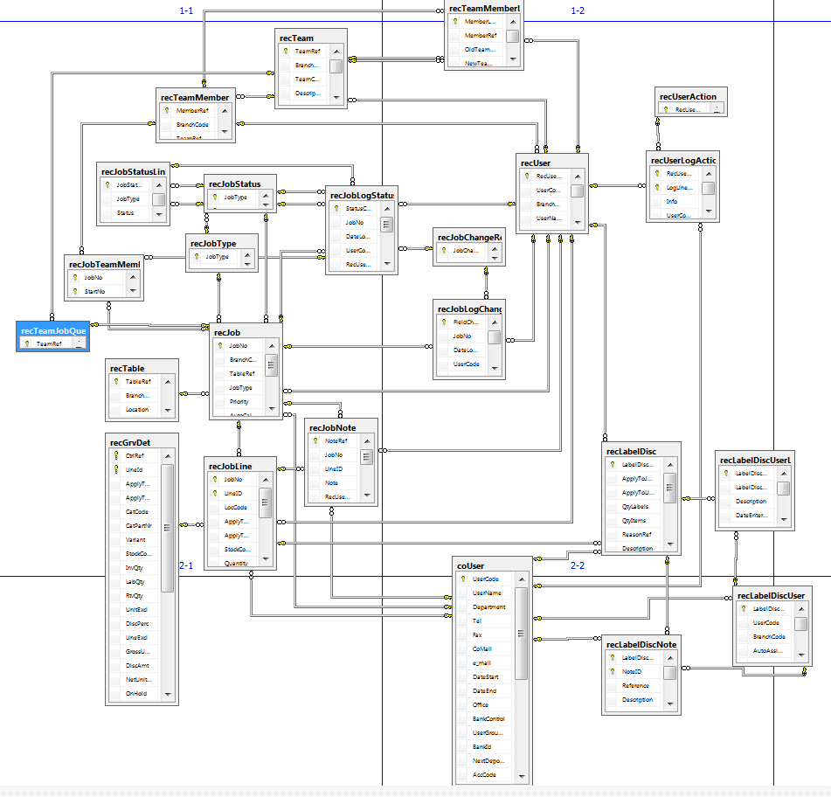

# Programs

# MS Windows Executables

|  |  |
| --- | --- |
| **Name** | **Description** |
| recJobAnnounce | Create a new job and capture related detail |
| recJobHandleDiscrepancies | Variance management on the job |
| recMaintainJobs |  |
| recMaintainLabelJobReason |  |
| recMaintainTeamSupplier |  |
| recMaintainUserTeamTable |  |
| recPrintBinningReport |  |
| recRFCCollectScanning | ePart delivery system integration to return supplier goods or to collect goods from supplier |

# SQL Stored Procedures

|  |  |
| --- | --- |
| **Name** | **Description** |
| recBinningReportAlternateBins.sql | View where the processed goods must be binned |
| recBinningReportFirstPrint.sql |  |
| recBinningReportParamsAdd.sql |  |
| recBinningReportReprint.sql |  |
| recEMailDiscrepancyList.sql |  |
| recGRVCaptureSerial.sql |  |
| recGRVCheckInvDate.sql |  |
| recGRVGetSerialCaptureList.sql |  |
| recGRVPrint.sql |  |
| recLabellingDiscrepancyList.sql |  |
| recProcCheck.sql |  |
| recRptBinnerPerformance.sql |  |
| recRptLabellingTeamTimes.sql |  |
| recRptTransferSuspense.sql |  |
|  |  |

# 

# Triggers

|  |  |
| --- | --- |
| **Name** | **Description** |
| recJobLineAutoCalcPriorityOnIU.sql | Assists in pre-calculating priority for jobbing & labelling |

# Acceptance

I hereby confirm that I have been fully informed of the documents content and, received training to understand how the detailed instructions are to be applied

Name …………………………………………………………………………….

Job Title ………………………………………………………………………….

Signed ……………………………………………………………………………

Date ………………………………………………………………………………